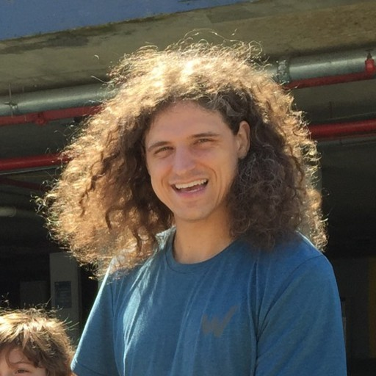
Consultant Profile:
Brian Sparrow

Brian is a highly skilled Software Engineer with over 15 years of experience in the industry. Throughout his career, he has collaborated with numerous talented developers and teams, acquiring deep expertise in software testing and development. Recognizing that success in software engineering requires collaboration, Brian excels in team-oriented environments, where his ability to work cohesively and effectively is evident.

Personal
Based in: Annapolis, Maryland (able to travel) UTC -4
Education: B.E. Electrical Engineering and Engineering Management
Work Experience: 15 Years in Software, IT, and DevOps roles. 10 Years of Erlang Experience
Core skills:  - Design of functional, scalable systems  - Failure models and chaos engineering  - Database design and operation  - Software Testing  (unit, integration, and system levels)  - Debugging systems  - Full Stack development and operations  - Creation of technical documentation,  including requirements, architecture  and test specifications.  - Excellent verbal and written communication | Technologies used:  - Elixir, Erlang/OTP  - Python, C++, C#, JAVA, Go  - Phoenix Live-view, EUnit, QuickCheck, Tsung  - Unix/Linux/BSD/Solaris/WinServerEnvironments  - CI/CD, Terraform, Puppet, Chef, CDK, Pulumi, Ansible  - SQL/NoSQL, PL/SQL, ORACLE, MapReduce, GraphQL  - Container orchestration(ECS, K8s)  - Cloud providers (AWS, GCP, etc)
Highlighted Projects
Back Creek Software – Consulting on Riak operations, performance, and stability

I own and operate an independent Software Consulting firm that helps local and international clients with specific needs. I have consulted for TI Tokyo(OpenRiak Founders) on many Riak installations with responsibilities ranging from operational needs, database/system tuning, on-call/break-fix support, and custom feature development.

BlockFi - Head of Platform Engineering

Very early engineering hire and was initially responsible for migrating existing Elixir applications from a legacy monolith running on 2 EC2 instances to microservice architecture orchestrated by ECS to support scaling and flexibility as the company grew. Hired and led a team of 8 globally distributed engineers to handle all cloud infrastructure and on-call responsibilities. Responsible for security and stability of core Elixir services, databases, and cloud infrastructure.

We were also responsible for the developer experience at the company and reworked the CI/CD pipeline to include automated unit testing, property based testing, and a comprehensive Tsung(Erlang load testing tool) load testing suite to support and test for massive customer growth(1000x).

Riot Games - Tech Lead on Social Infrastructure team(Erlang Social Services)

Key engineer on major projects supporting migration from single game ecosystem to multi-game social platform. Worked with a team of 4 engineers to upgrade/rework chat service(ejabberd) to support multi-cluster and multi-game operations. Primary engineer for new Friends Forever Service(FFS) which was an Erlang service responsible for migrating friends from a League of Legends specific context to a multi-game context with a new API, database layer, and operational expectations.

Worked with another engineer to implement Player Affinity Service(PAS), a riak-core like Erlang hashing/sharding/routing layer which allowed other game teams to route messages, matchmaking, notification, etc. to any social cluster depending on real-world player location and other performance factors. PAS allowed for players and developers across games and regions to chat, become friends, send gifts, etc. through a single API which dramatically decreased operational complexity and developer pain while interacting with global social functions.

I was the most experienced Erlang engineer on the team and as such took responsibility for much of the on-call and operations support of Erlang services as well as training for less experienced engineers in how to operate and debug Erlang services. Also responsible for operations and support for all Riak installations at Riot Games and regularly gave tech talks and seminars on Erlang, Riak, and our new Erlang systems to support the multi-game platform.

Workiva - Cloud Operations and Orchestration

I was the technical lead for the container orchestration system as well as head of cloud operations. I developed a prototype to migrate backend systems from managed Kubernetes(EKS) to a self-managed environment with additional deployment features and testing not yet available in EKS. This project saved 10’s of thousands in cloud costs in the first year alone.

My team and I were also responsible for cloud operations which included database management, identify management, and NATS messaging system management. Regularly on-call for critical systems and responsible for developing and adding new features to NATS Go client library.

Basho Technologies - Senior Engineer(Support, Professional Services, Development)

Started at Basho Technologies as a Support Engineer helping customers deploy, manage, and fix Riak/RiakS2/RiakTS database installations. Regularly on-call for 100’s of customer clusters and handled many high intensity and business critical emergencies. Regularly traveled to customer sites to prototype, deploy, or fix Riak clusters as well as give training to engineers and non-technical audiences about NoSQL and Riak/Erlang.

Eventually was promoted to a Senior Engineer on the core development team, working on new features and bug fixes for riak-core, bitcask, riak_kv, and enterprise features such as multi-datacenter replication.

ARINC - Senior Engineer(JAVA/Python)

I was responsible for adding new features to our in-cockpit communication system in accordance with customer needs and SEI/ISO 9001 engineering process. Worked in JAVA to add new GUI features and Python to add new capabilities to our messaging system which sent ACARS messages from ground stations to the cockpits to communicate weather, gate/airport/runway, and other necessary information to pilots.

I led a team of one other engineer in implementing a new test bed for all of our new feature work for the GLOBALink team. This simulated all parts of the system from the ground stations at the airports to the cockpits connected to radio towers and was eventually added to our waterfall development/test process for all new features and bug fixes.

MI-Corporation - Software Engineer(C#/VB .NET)

Small company of 4 engineers which developed custom e-forms software for hospitals and other public service entities called Mi-Forms. Was primarily responsible for testing new features and developing tests and simulating customer sites. Most work was in C#/VB .NET but also needed to develop some custom logic on our backend Sharepoint Servers. I was responsible for managing all backend services and databases and was on-call for these critical systems.

Career
Back Creek Software - Founder (Annapolis, MD)
August 2022 - Present

BlockFi - Principal Engineer (Remote)
June 2020 - August 2022

Riot Games - Senior Engineer (St. Louis, MO)
June 2018 - June 2020

Workiva - Senior Engineer (Ames, IA)
June 2017 - June 2018

Basho Technologies - Senior Engineer (Remote)
January 2012 - June 2017

ARINC(Collins Aerospace) - Software Engineer (Annapolis, MD)
March 2010 - December 2011

MI-Corporation - Software Engineer (Durham, NC)
December 2007 - February 2010

Education
Duke University
2009-2010
Left PhD in Biomedical Engineering program early to pursue other opportunities
Vanderbilt University
2005-2009
Bachelors of Engineering, Honors in Electrical Engineering and Engineering Management
Summa cum laude

